Active Directory Installation Guide

La Trobe

**Author** Vinci Parashar, Softedge Systems, India

**Project** La Trobe RIC

**Date Created** 9th October 2012

**File Name** AD Installation

|  |  |
| --- | --- |
| **Doc ID** | **La Trobe Active Directory Installation Guide** |
| **Date** | **09/10/12** |
| **Revision** | **V3.0.0.0** |
| **Project Name** | **La Trobe** |
| **Project Number** |  |
| **Status** |  |

**La Trobe Active Directory Installation Guide**

# Abstract

The Research Information Centre 2.0, otherwise known as VRE Toolkit for SharePoint, is a virtual environment for researchers to manage their research process and the digital artifacts that are created, including sharing and communally working on them. It facilitates:

* A single environment available to researchers allowing them to access and manage all aspects of their work.

An integrated, structured way for individuals and groups of researchers to have access to content, tools and other resources such as people and organizations.

Approvals

|  |  |  |
| --- | --- | --- |
| **Approvals** | **Signed** | **Date** |
| **Author:** | Vinci Parashar | 09/10/12 |
| **Title:** | Project Owner, Softedge |  |
| **Reviewer:** |  |  |
| **Title:** |  |  |
| **Approver 1:** | Anu Sahni |  |
| **Title:** | CTO, Softedge |  |
| **Approver 2:** | Jason Tan |  |
| **Title:** |  |  |
| **Approver 3:** |  |  |
| **Title:** |  |  |

# Revision History

|  |  |  |  |
| --- | --- | --- | --- |
| **Revision** | **Release Date** | **Author/Reviewer** | **Reason for Change** |
| V0.1 | 25/01/12 | Vinci Parashar | 1st Draft |
| V1.2 | 23/02/2012 | Vinci Parashar | Changes in WSPs |
| V3.0.0.0 | 09/10/2012 | Vinci Parashar | Changes in WSPs |
| V0.4 |  |  |  |
| V0.5 |  |  |  |
| V1.0 |  |  |  |

Table of Contents

Abstract 2

Revision History 3

1. Introduction 5

1.1 Purpose of the Document 5

1.2 Definitions, Acronyms, and Abbreviations 5

1.3 System Requirements 5

1.4 Platform Requirements 7

1.5 The following installation has been done on the following platform 7

2. Create Active Directory on Windows Server 2008 R2 (Server 1) 9

3. Create Organizational Unit 22

4. Creating Groups 27

5. Adding Users to the Groups 31

6. Creating System Users 58

# 1. Introduction

## 1.1 Purpose of the Document

The purpose of this document is to provide AD Creating Guide for the **La Trobe V3.0.0.0**, providing step-by-step instructions on created the Active Directory, Adding Groups to Active Directory, Adding Users to Groups and Adding System Users.

## 1.2 Definitions, Acronyms, and Abbreviations

RIC Research Information Centre

AD Active Directory

## 1.3 System Requirements

**Hardware requirements**—**Web servers, application servers, and single server installations**

The following requirements apply both to installations on a single server with a built-in database and to servers running SharePoint Server 2010 in a multiple server farm installation.

*Minimum Requirements*

Processor

64-bit, four cores

RAM

4 GB for developer or evaluation use

8 GB for production use in a single server or multiple server farms

Hard Disk

80 GB for System Drive. You must have sufficient space for the base installation and sufficient space for diagnostics such as logging, debugging, creating memory dumps, and so on. For production use, you also need additional free disk space for day-to-day operations. Maintain twice as much free space as you have RAM for production environments.

**Hardware requirements—Database servers**

The following requirements apply to database servers in production environments with multiple servers in the farm.

*Minimum Requirements*

Processor

64-bit, four cores for small deployments

64-bit, eight cores for medium deployments

RAM

8 GB for small deployments

16 GB for medium deployments

Hard Disk

80 GB for system drive

Hard disk space is dependent on the size of your SharePoint content

**Software requirements**

The following requirements apply to single server with built-in database installations and server farm installations that include a single server and multiple servers in the farm.

***NOTE****: The Microsoft SharePoint Products Preparation Tool — which you access from the SharePoint Server 2010 Start page — can assist you in the installation of the software prerequisites for SharePoint Server 2010.*

*Minimum Requirements*

Database server in a farm

One of the following:

The 64-bit edition of Microsoft SQL Server 2008 R2

The 64-bit edition of Microsoft SQL Server 2008 with Service Pack 1 (SP1) and CU 2

The 64-bit edition of Microsoft SQL Server 2005 with Service Pack 3 (SP3) and Cumulative update package 3 for SQL Server 2005 Service Pack 3

Single server with built-in database

The 64-bit edition of Windows Server 2008 Standard, Enterprise, Data Center, or Web Server with SP2; the 64-bit edition of Windows Server 2008 R2 Standard, Enterprise, Data Center, or Web Server; or the 64-bit edition of Windows Server 2008 R2 Service Pack 1 (SP1) Standard, Enterprise, Data Center, or Web Server. If you are running Windows Server 2008 without SP2, the Microsoft SharePoint Products Preparation Tool installs Windows Server 2008 SP2 automatically.

You must download an update for Windows Server 2008 and Windows Server 2008 R2 before you run Setup. The update is a hotfix for the .NET Framework 3.5 SP1 that is installed by the Preparation tool.

* + For Windows Server 2008 SP2, download the Windows6.0-KB979917-x64.msu (Vista) file.
  + For Windows Server 2008 R2, download the Windows6.1-KB979917-x64.msu (Win7) file.

The preparation tool will then install all of the necessary prerequisites, including Web Server IIS role, .Net Framework 3.5 SP1 among others.

Front-end Web servers and application servers in a farm

The same as Single server with built-in database as described above.

For a complete list of Hardware and Software Requirements for SharePoint Server 2010, please see;

[***http://technet.microsoft.com/en-us/library/cc262485.aspx***](http://technet.microsoft.com/en-us/library/cc262485.aspx).

Other software that may be required – Visual Studio 2010.

## 1.4 Platform Requirements

This installation was tested on the following systems:

**Server side:**

* Intel(R) Xeon 3.00GHz CPU 64-bit Server with 4GB RAM
* Windows Server 2008 R2 (Enterprise Edition)
* SQL Server 2008 R2
* SharePoint Server 2010

And

* Intel(R) Xeon 3.00GHz CPU 64-bit Server with 8GB RAM
* Windows Server 2008 R2 (Enterprise Edition)
* SQL Server 2008 R2
* SharePoint Server 2010

**Client side:**Internet Explorer 8

## 1.5 The following installation has been done on the following platform

* Operating System: Windows Server 2008 R2 Enterprise
* RAM: 4GB
* Processor: Intel(R) Core(TM)2 Duo CPU E7500 @ 2.93GHz 2.93 GHz
* Hard Disk: 240GB

# 2. Create Active Directory on Windows Server 2008 R2 (Server 1)

**NOTE**: Please amend the paths, system name, SMTP configurations according to your deployment environment. The screenshots given below are just illustrators

**NOTE**: The PC names of all the three servers (AD, SQL Server and SharePoint) should be different

1. Click **Start** 🡪 **Run…**

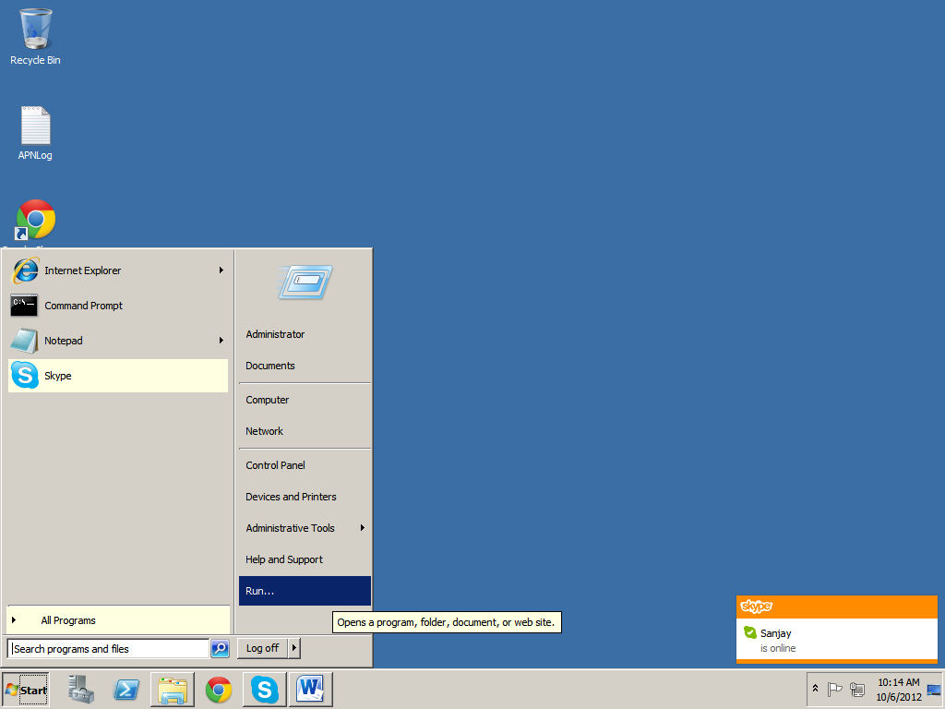

1. Enter **DCPROMO**. Click **OK**

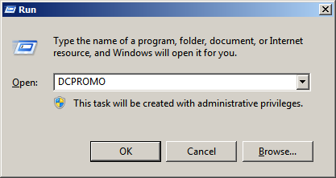

1. Following screen appears

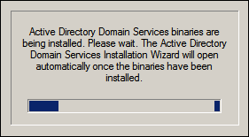

1. Click **Next**

**NOTE**: Make sure the checkbox “**Use advanced mode installation**” is **disabled**

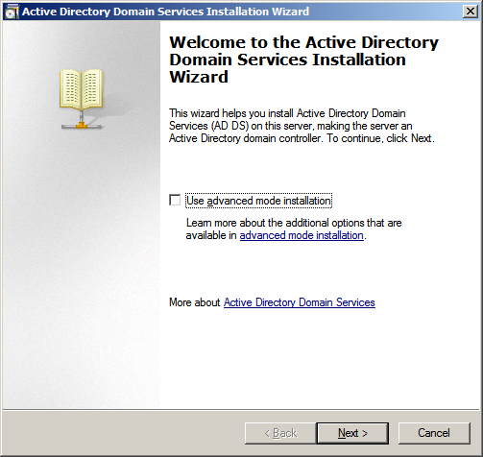

1. Click **Next**

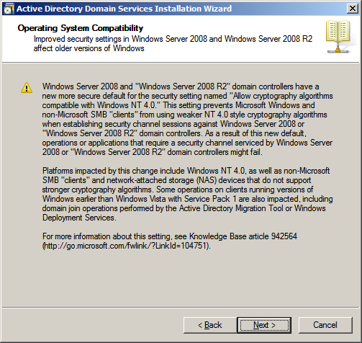

1. **Enable** the radio button **Create a new domain in a new forest**. Click **Next**

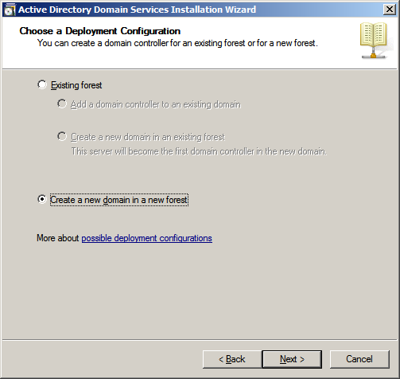

1. Enter the **domain name**. Click **Next**

**NOTE**: For example, the **domain name** in our case is **sharepoint0.com**

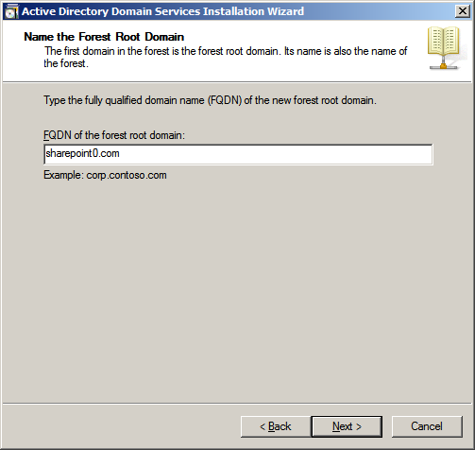

1. Following screen appears

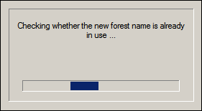

1. Select **Windows Server 2008 R2** from the drop down **Forest functional level**

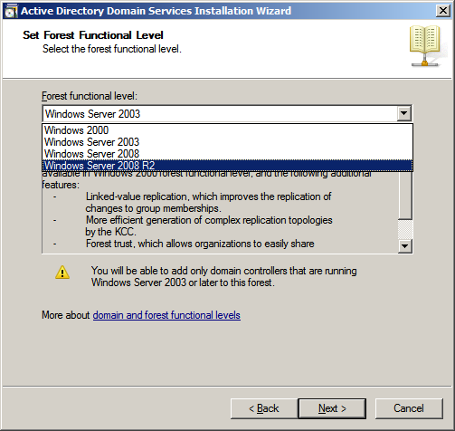

1. Click **Next**

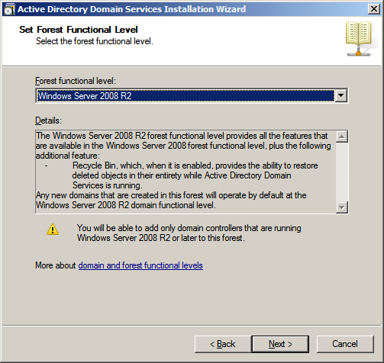

1. Click **Next**

**NOTE**: Make sure the check box **DNS server** is **enabled**

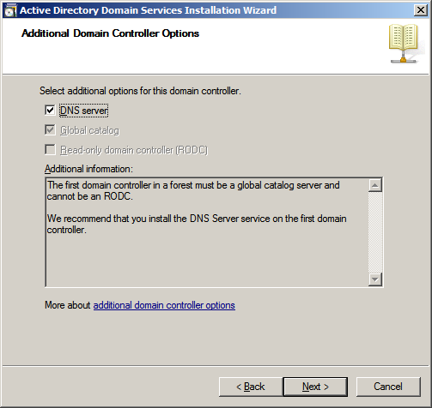

1. Following screen appears

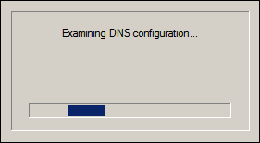

1. Click **Yes**

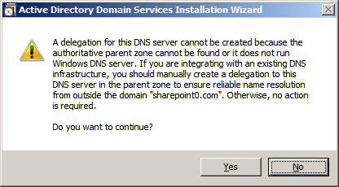

1. Click **Next**

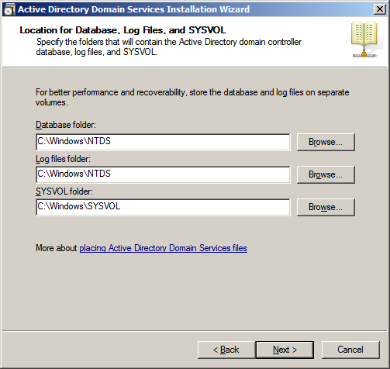

1. Enter **Password** and **Confirm password**. Click **Next**

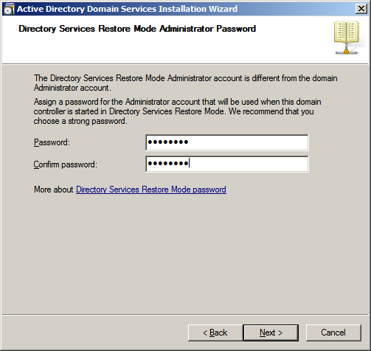

1. Click **Next**

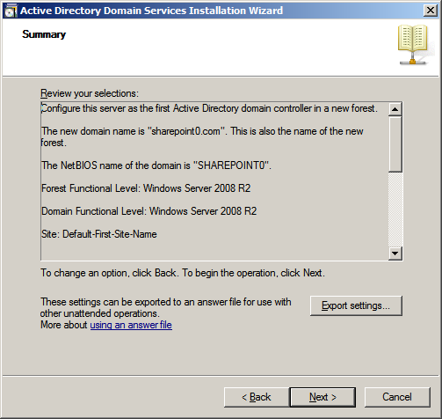

1. **Disable** the checkbox **Reboot on completion**

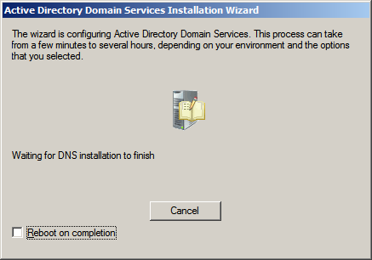

1. Click **Finish**

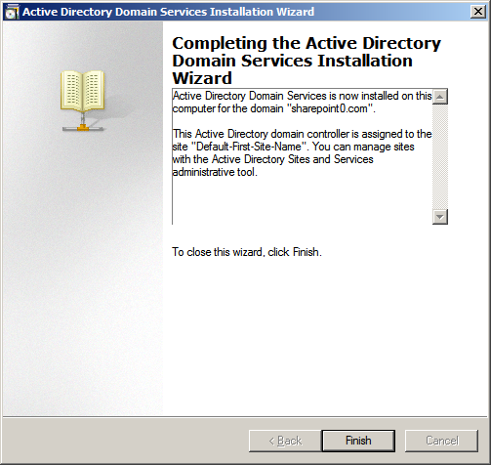

1. Click **Restart Now**

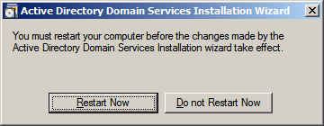

# 3. Create Organizational Unit

1. Click **Start** 🡪 **Administrative Tools** 🡪 **Active Directory Users and Computers**

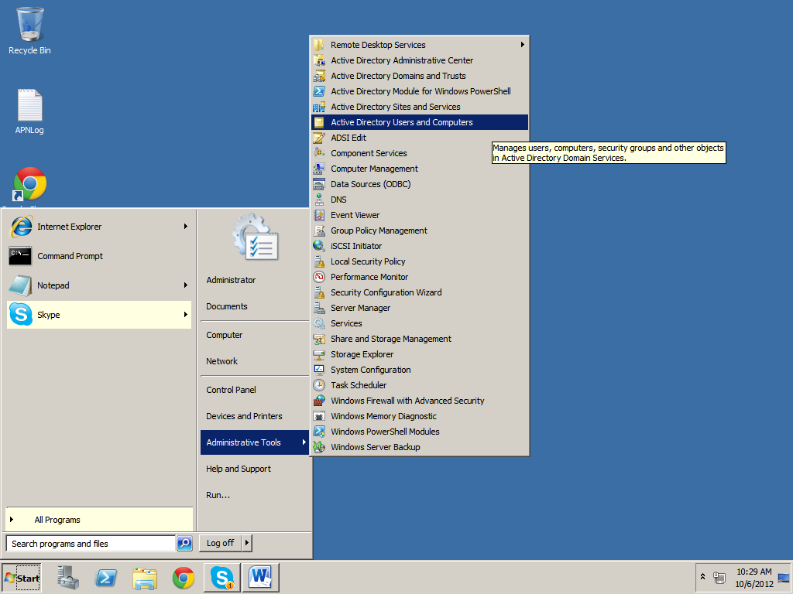

1. **Right click** on the **domain name**. Click **New** –> **Organizational Unit**

**NOTE:** For example, the **domain name** in our case is **sharepoint0.com**

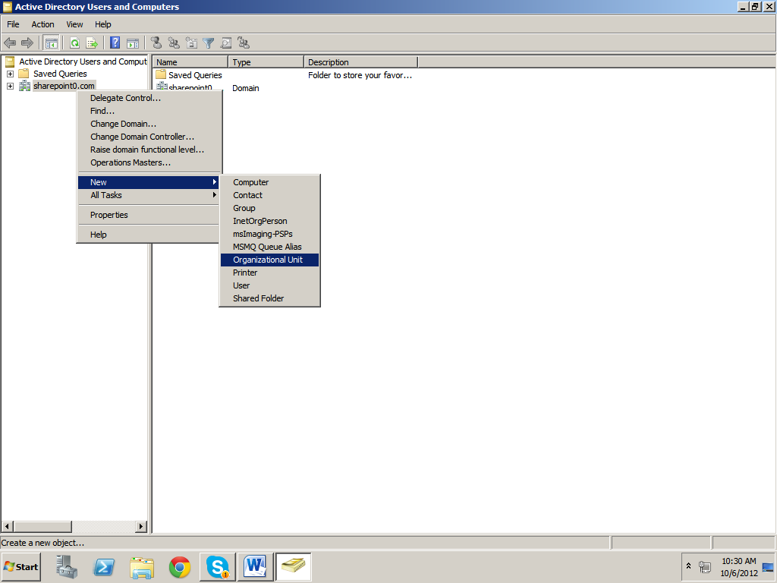

1. Enter the **Name** of the organizational unit. Click **OK**

**NOTE**: For example, the name of the organizational unit in our case is **LaTrobe**

**NOTE**: Make sure the checkbox “**Protect container from accidental deletion**” is **enabled**

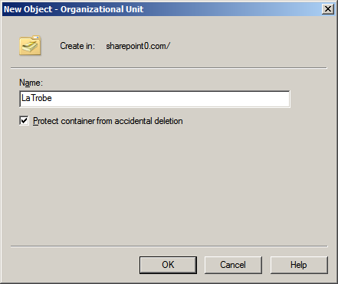

1. Click on the **+** Sign corresponding to the **domain name**

**NOTE**: For example, the **domain name** in our case is **sharepoint0.com**

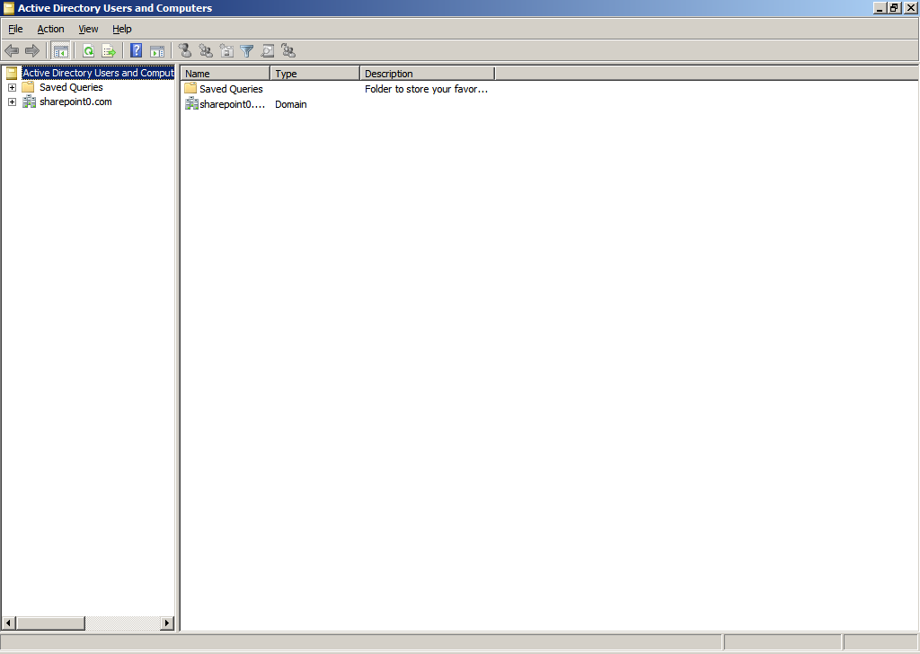

1. **Right click** on the **organizational unit** just created. Click **New** 🡪 **Organizational Unit**

**NOTE**: For example, the **organizational unit** just created in our case is **LaTrobe**

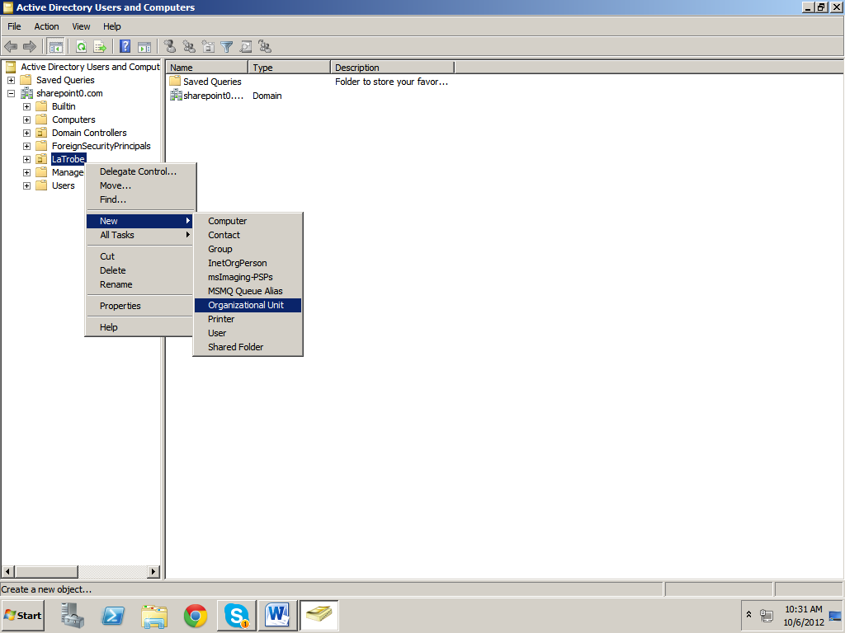

1. Enter the **Name** of the organizational unit. Click **OK**

**NOTE**: For example, the **organizational unit** in our case is **LaTrobe Viewer**

**NOTE**: Make sure the checkbox “**Protect container from accidental deletion**” is **enabled**

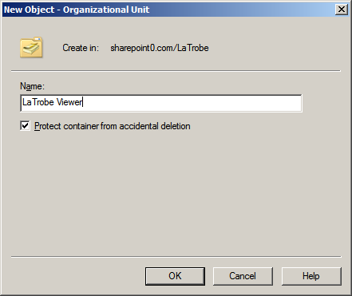

1. **Right click** on the **organizational unit** created in **step 22**. Click **New** 🡪 **Organizational Unit**

**NOTE**: For example, the organizational unit created in our case is **LaTrobe**

**NOTE**: Make sure the checkbox “**Protect container from accidental deletion**” is **enabled**

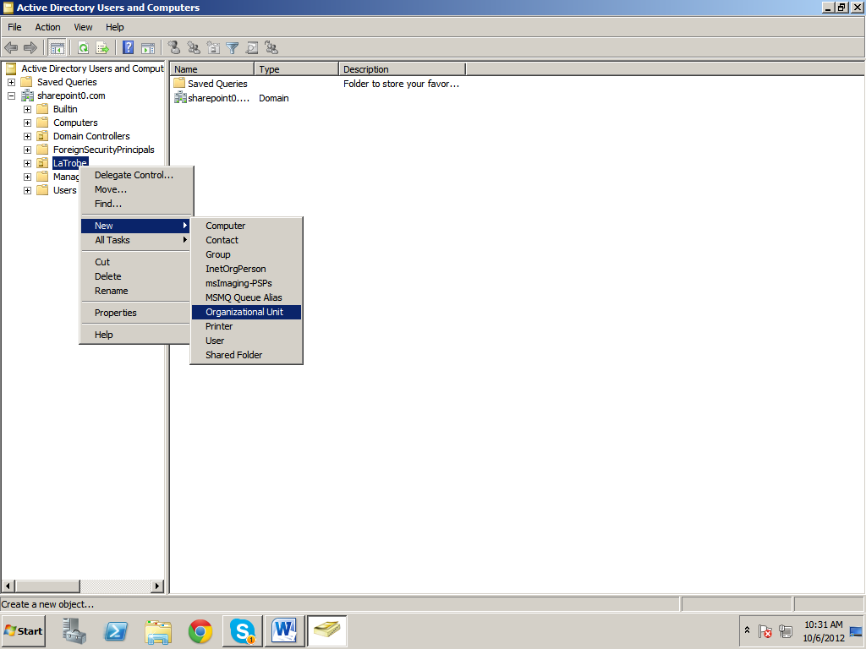

1. Enter the **Name** of the organizational unit. Click **OK**

**NOTE**: For example, the name of the **organizational unit** in our case is **LaTrobe Member**

**NOTE**: Make sure the checkbox “**Protect container from accidental deletion**” is **enabled**

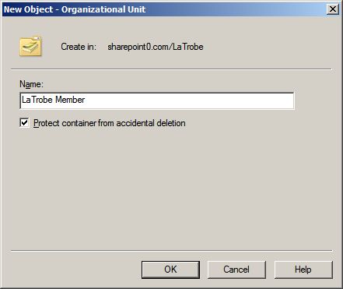

1. **Right click** on the **organizational unit** created in **Step 22**. Click **New** 🡪 **Organizational Unit**

**NOTE**: For example, the **organizational unit** created in our case is **LaTrobe**

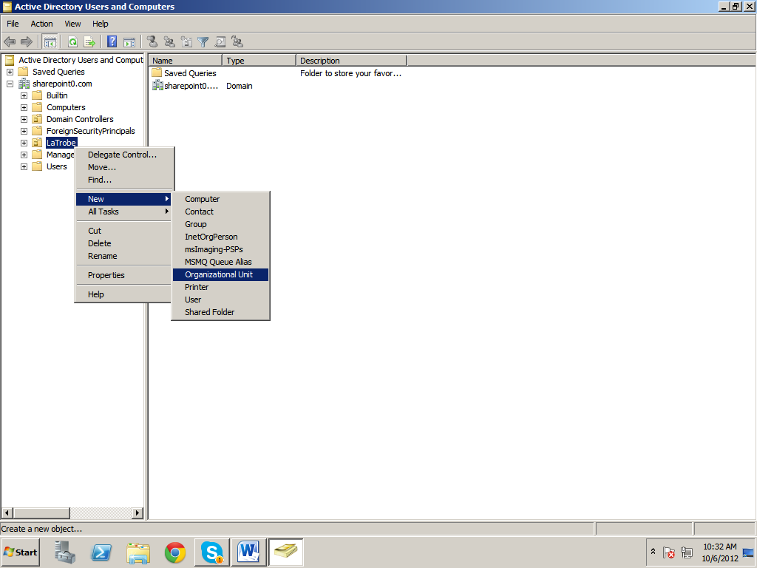

1. Enter the **Name** of the organizational unit. Click **OK**

**NOTE**: For example, the **organizational unit** in our case is **LaTrobe Owner**

**NOTE**: Make sure the checkbox “**Protect container from accidental deletion**” is **enabled**

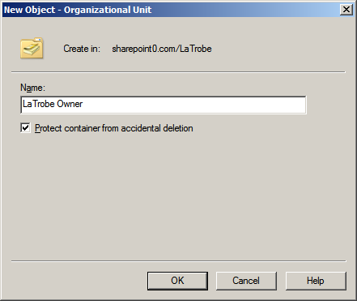

# 4. Creating Groups

1. Click on the **+** sign corresponding to the **organizational unit** created in **Step 22**

**NOTE**: For example, **organizational unit** in our case is **La Trobe**

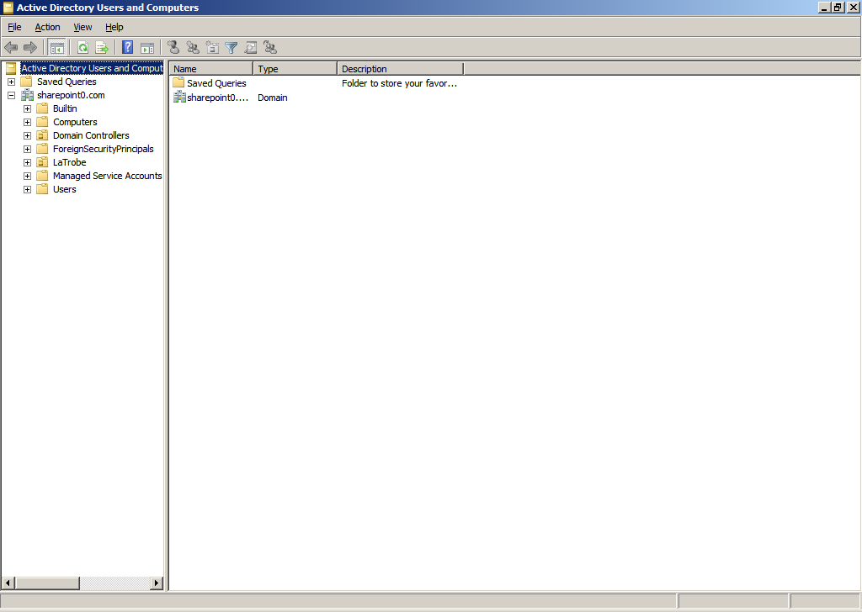

1. **Right click** on the **organizational unit** created in **Step 25**. Click **New** 🡪 **Group**

**NOTE**: For example, the **organizational unit** created in our case is **LaTrobe Viewer**

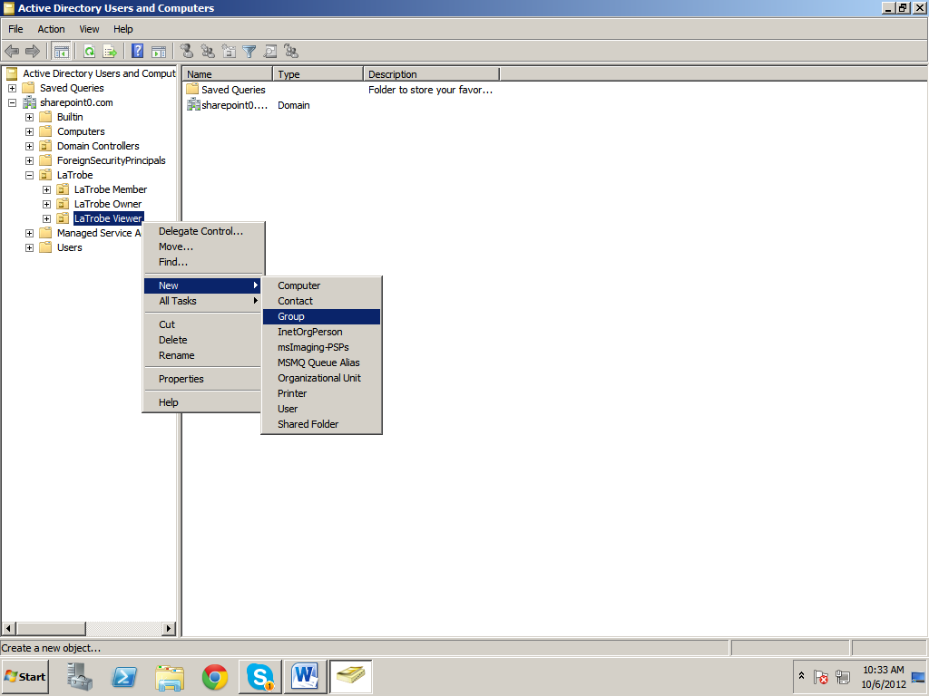

1. Enter the **Group name**. Click **OK**

**NOTE**: For example, the **Group name** in our case is **LaTrobe Viewer**

**NOTE**: Make sure the radio button **Global** is **selected** under **Group scope** and the radio button **Security** is **selected** under **Group type**

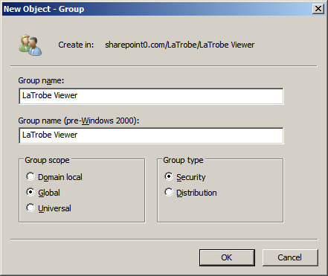

1. **Right click** on the **organizational unit** created in **Step 27**. Click **New** 🡪 **Group**

**NOTE**: For example, the **organizational unit** created in our case is **LaTrobe Member**

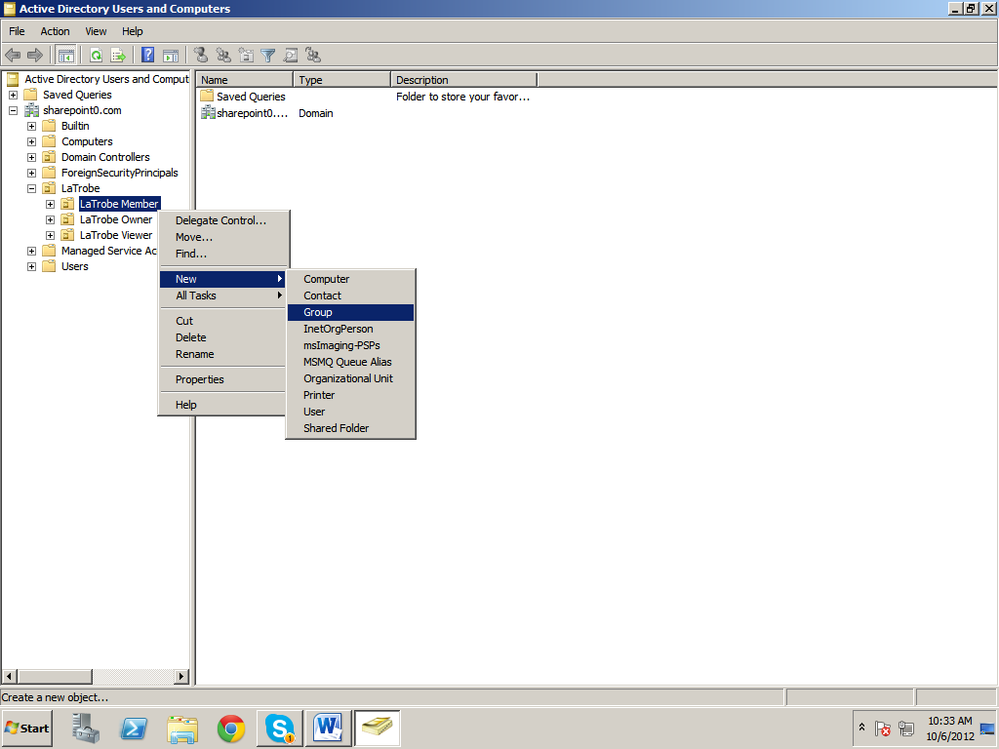

1. Enter the **Group name**. Click **OK**

**NOTE**: For example, the **Group name** in our case is **LaTrobe Member**

**NOTE**: Make sure the radio button **Global** is **selected** under **Group scope** and the radio button **Security** is **selected** under **Group type**

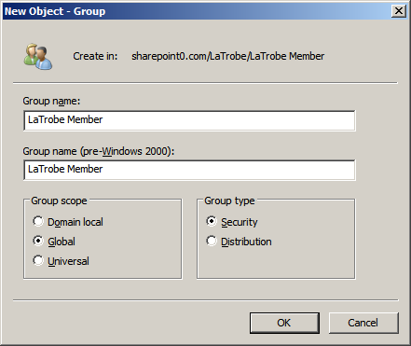

1. **Right click** on the **organizational unit** created in **Step 29**. Click **New** 🡪 **Group**

**NOTE**: For example, the **organizational unit** created in our case is **LaTrobe Owner**

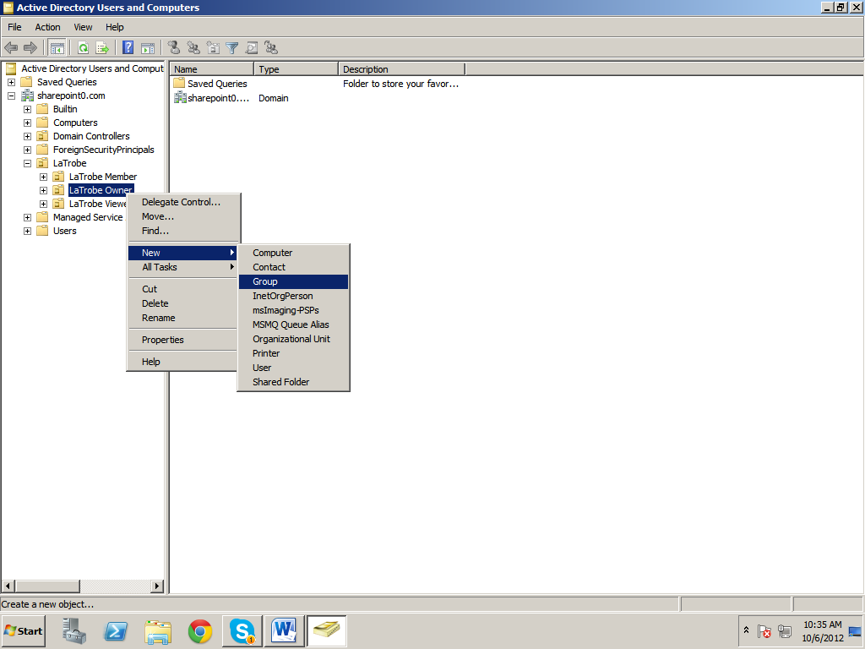

1. Enter the **Group name**. Click **OK**

**NOTE**: For example, the **Group name** in our case is **LaTrobe Owner**

**NOTE**: Make sure the radio button **Global** is **selected** under **Group scope** and the radio button **Security** is **selected** under **Group type**

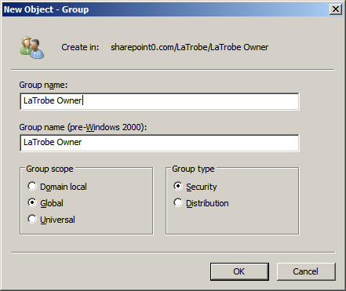

# 5. Adding Users to the Groups

1. **Right click** on the **group** created in **Step 32**. Click **New** 🡪 **User**

**NOTE**: For example, the **group** created in our case is **LaTrobe Viewer**

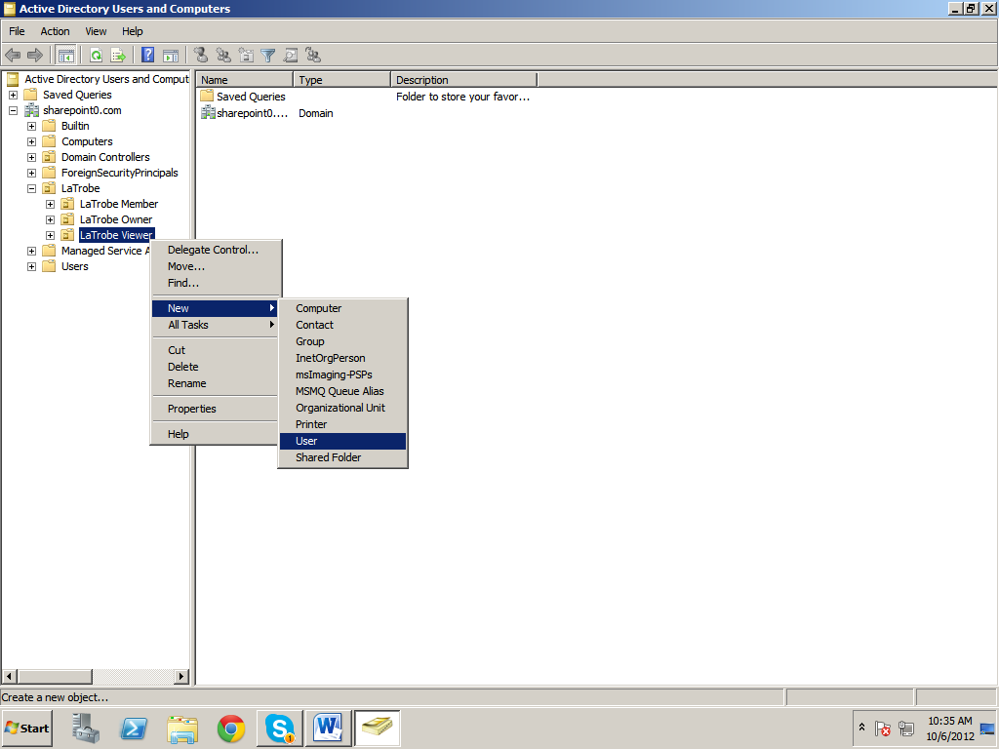

1. Enter the **details**, that is, **First name, Initials, Last name** and **User logon name**. Click **Next**

**NOTE**: For example, **First name** is **Mark**, **Last name** is **Kosten** and **User logon name** is **mark** in our case

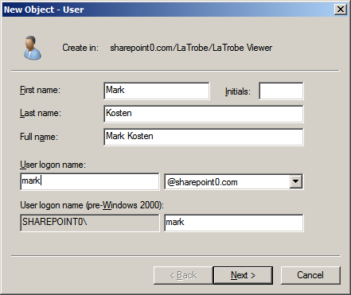

1. Enter **Password** and **Confirm Password**. **Disable** the checkbox **User must change password at next logon**. **Enable** the following checkboxes
2. **User cannot change password**
3. **Password never expires**

**NOTE**: Make sure the checkbox **Account** **is disabled** has been **unchecked**

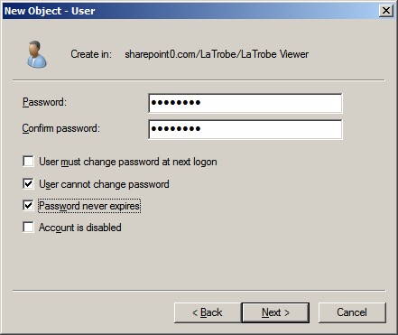

1. Click **Finish**

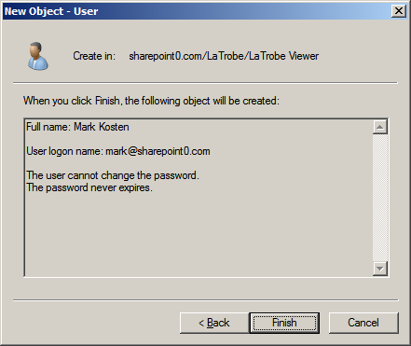

1. Click **LaTrobe Viewer**

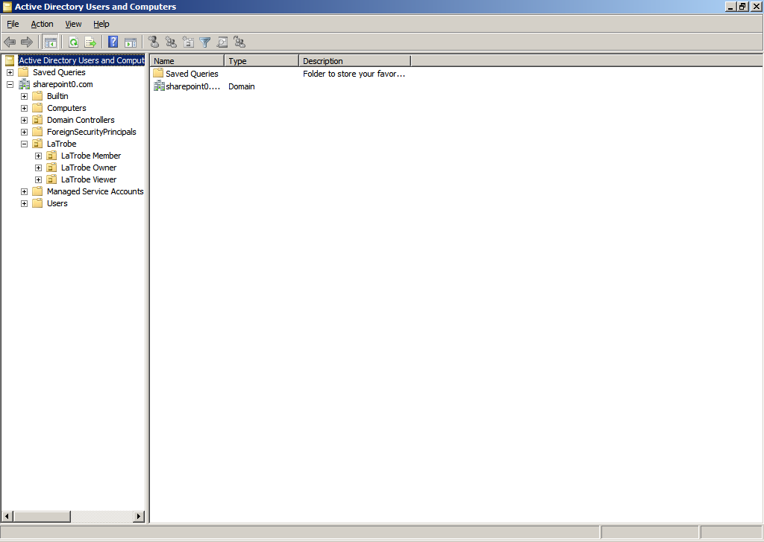

1. **Right click** on the **user** created in **Step 38**. Click **Properties**

**NOTE**: For example, **Mark Kosten** is the **user** in our case

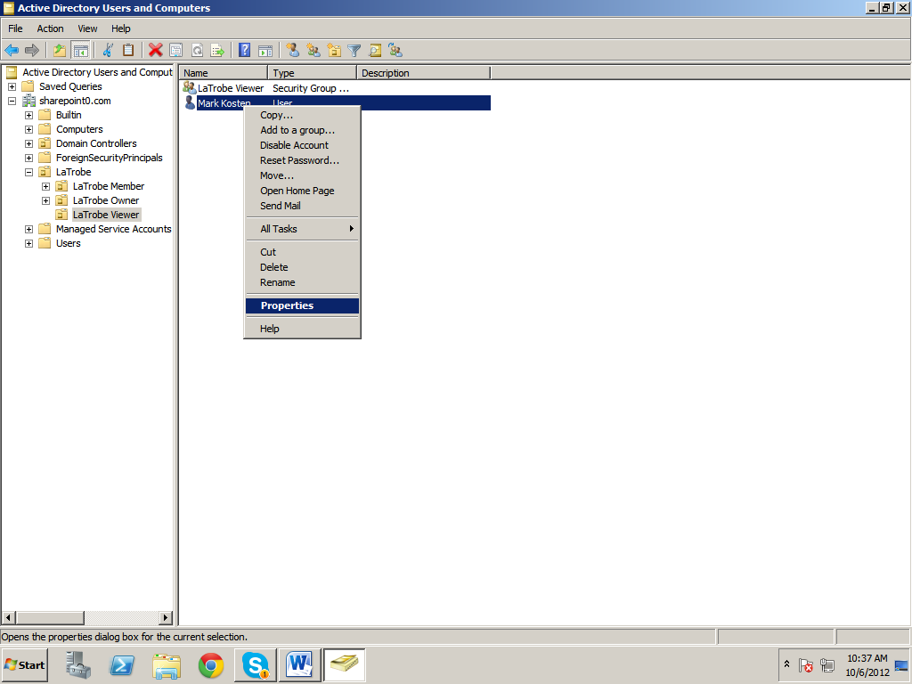

1. Enter **Email** address of the user. Click **Member Of**

**NOTE**: For example, the **email** in our case is [**m.kosten@latrobe.edu.au**](mailto:m.kosten@latrobe.edu.au)

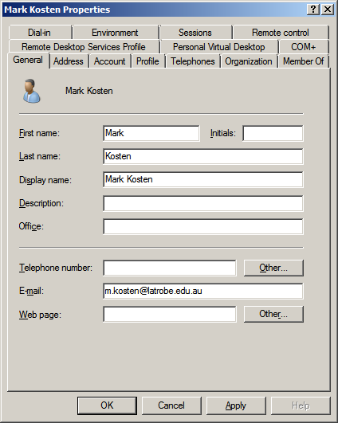

1. Click **Add**

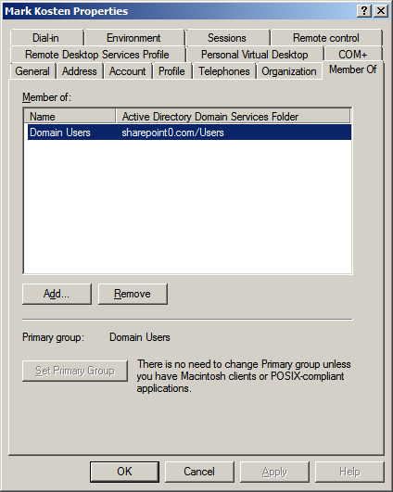

1. Click **Advanced**

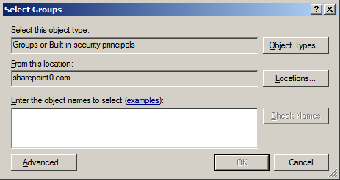

1. Click **Find Now**

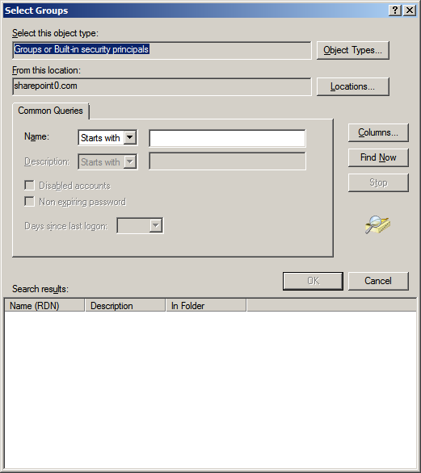

1. Select **LaTrobe Viewer** and click **OK**

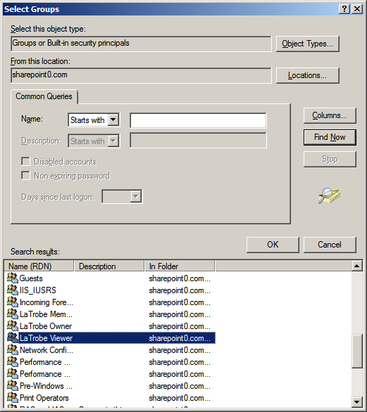

1. Click **OK**

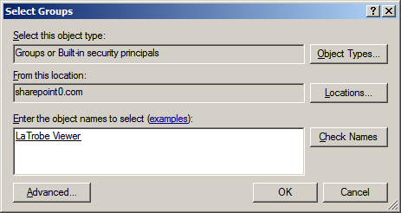

1. Click **Apply**

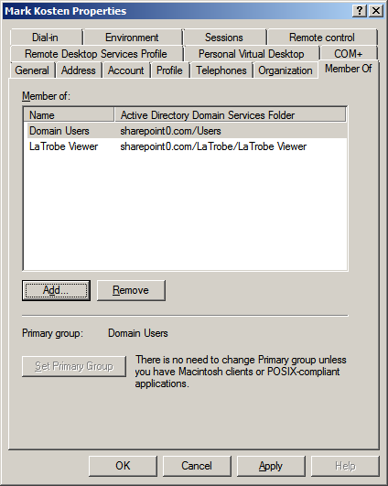

1. Click **OK**

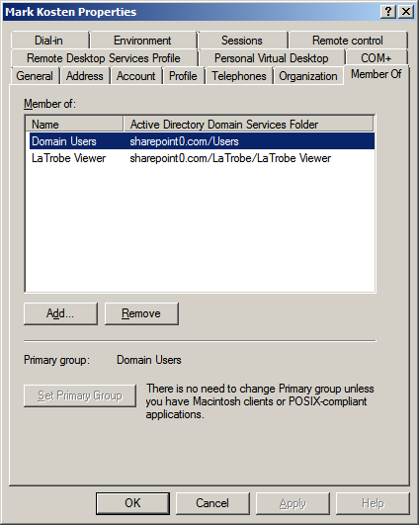

1. **Repeat** **Steps** **37 to 50** to **add additional users** in the group **LaTrobe Viewer**

**NOTE**: For example, we have added the **user** **Sanjay Singh** in the group **LaTrobe Viewer**

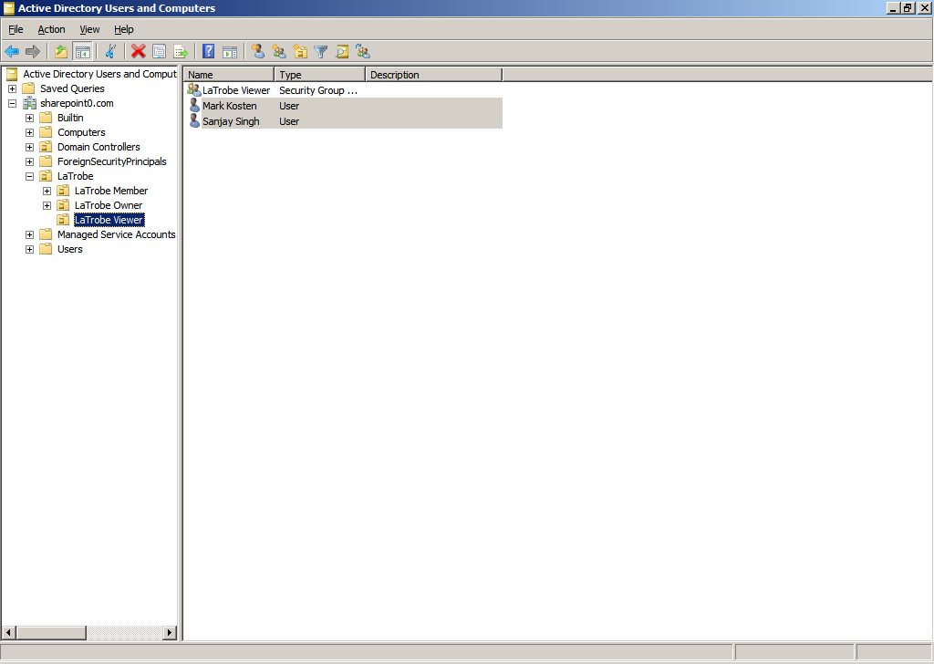

1. **Right click** on the **group** created in **Step 34**. Click **New** 🡪 **User**

**NOTE**: For example, the **group** created in our case is **LaTrobe Member**

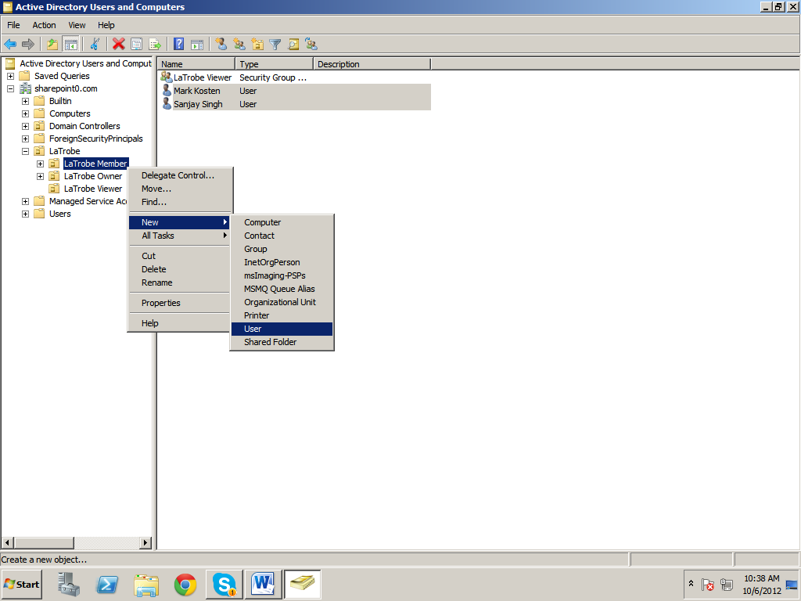

1. **Enter** the **details**, that is, **First name, Initials, Last name** and **User logon name**. Click **Next**

**NOTE**: For example**, First name** is **Bhupender**, **Last name** is **Bindra** and **User logon name** is **bhupender** in our case

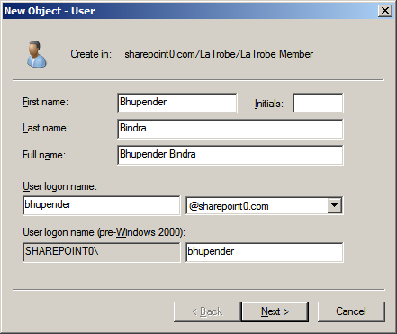

1. Enter **Password** and **Confirm Password**. **Disable** the checkbox **User must change password at next logon**. **Enable** the following checkboxes
2. **User cannot change password**
3. **Password never expires**

**NOTE**: Make sure the checkbox **Account is disabled** has been **unchecked**

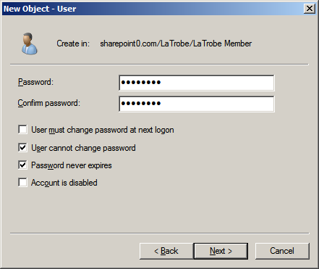

1. Click **Finish**

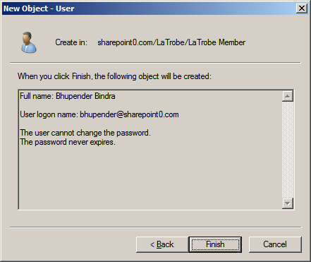

1. Click **LaTrobe Member**



1. **Right click** on the **user** created in **Step 46**. Click **Properties**

**NOTE**: For example, **Bhupender Bindra** is the **user** in our case

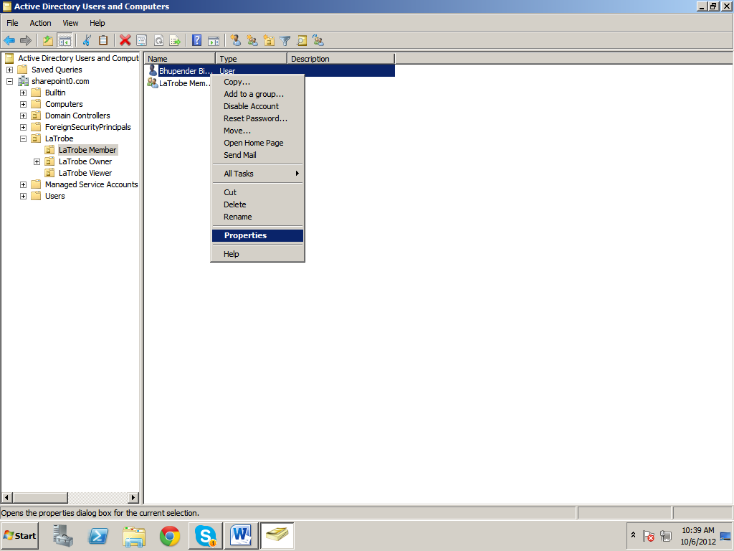

1. Enter **Email** address of the user. Click **Member Of**

**NOTE**: For example, the **email** is [**bhupender.bindra@softedge-systems.com**](mailto:bhupender.bindra@softedge-systems.com)

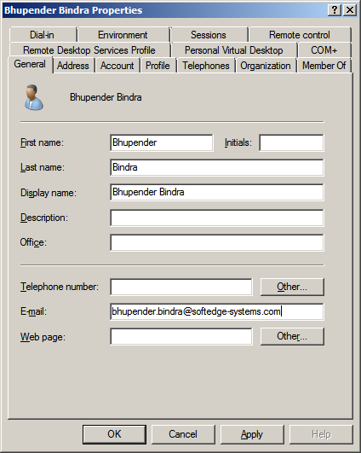

1. Click **Add**

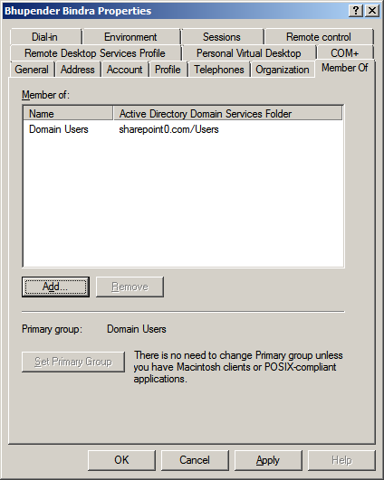

1. Click **Advanced**

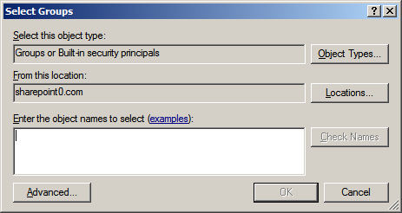

1. Click **Find Now**

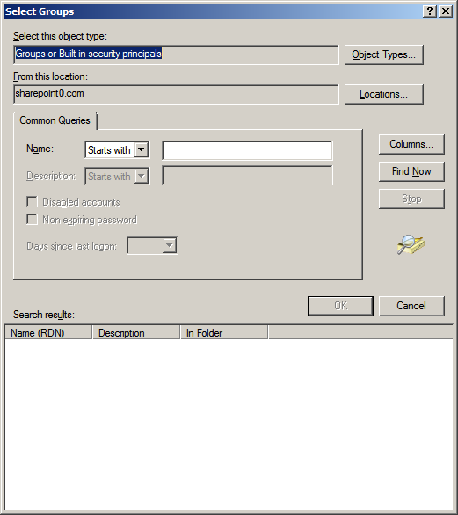

1. Select **LaTrobe Member** and click **OK**

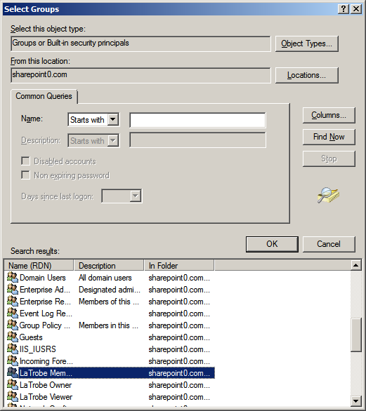

1. Click **OK**

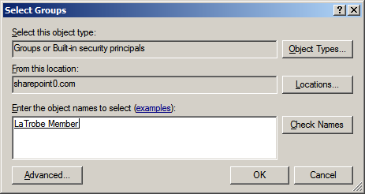

1. Click **Apply**

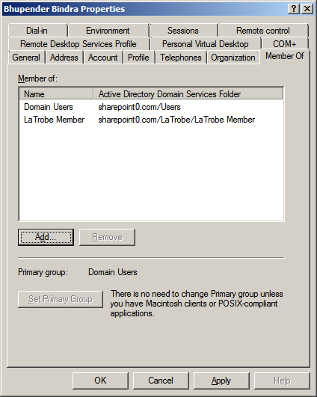

1. Click **OK**

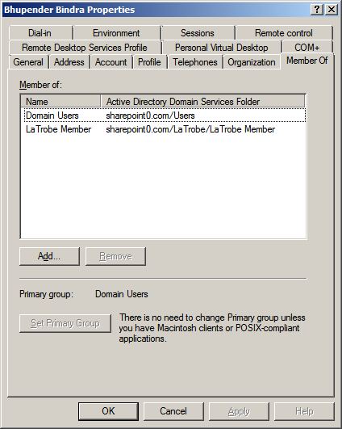

1. **Repeat** **Steps 52 to 65** to **add additional users** in the group **LaTrobe Member**

**NOTE**: For example, we have added **users** **Arvind Mishra** and **Rabindra Lal** in the group **LaTrobe Member**

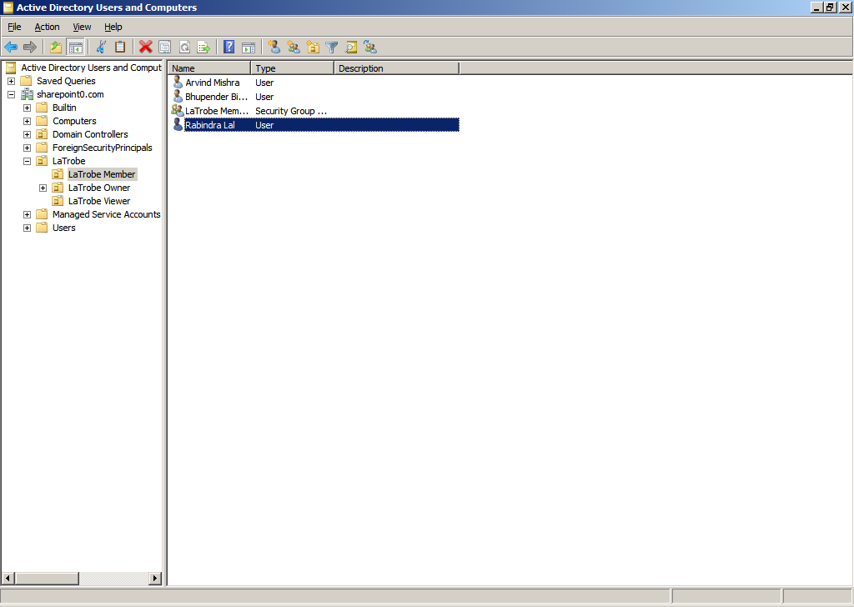

1. **Right click** on the **group** created in **Step 36**. Click **New** 🡪 **User**

**NOTE**: For example, the **group** created in our case is **LaTrobe Owner**

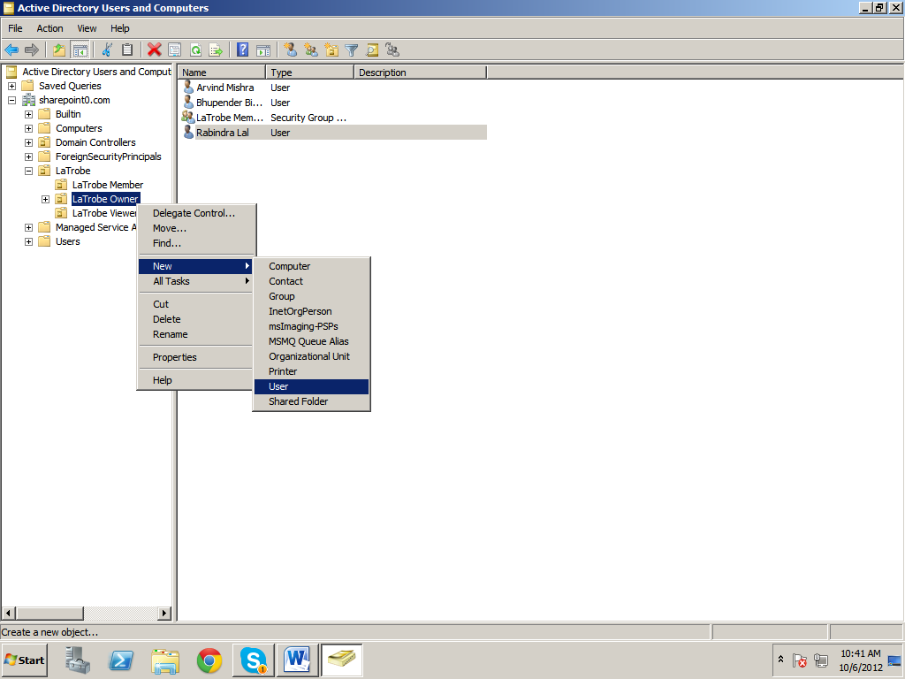

1. **Enter** the **details**, that is, **First name, Initials, Last name** and **User logon name**. Click **Next**

**NOTE**: For example, **First name** is **Anu**, **Last name** is **Sahni** and **User logon name** is **anu** in our case

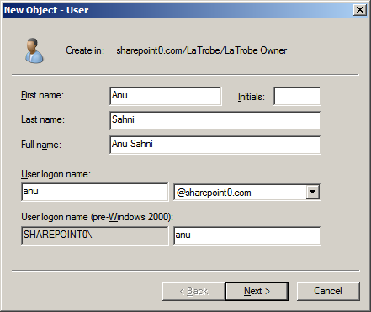

1. Enter **Password** and **Confirm Password**. **Disable** the checkbox **User must change password at next logon**. **Enable** the following checkboxes
2. **User cannot change password**
3. **Password never expires**

**NOTE**: Make sure the checkbox **Account is disabled** has been **unchecked**

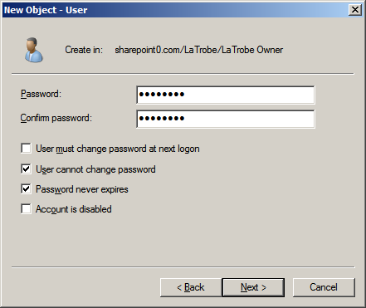

1. Click **Finish**

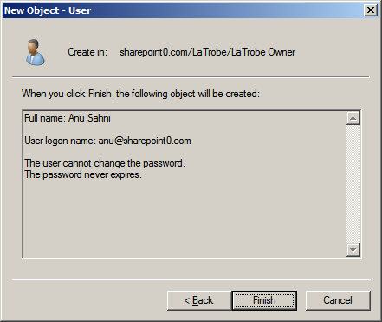

1. Click **LaTrobe Owner**

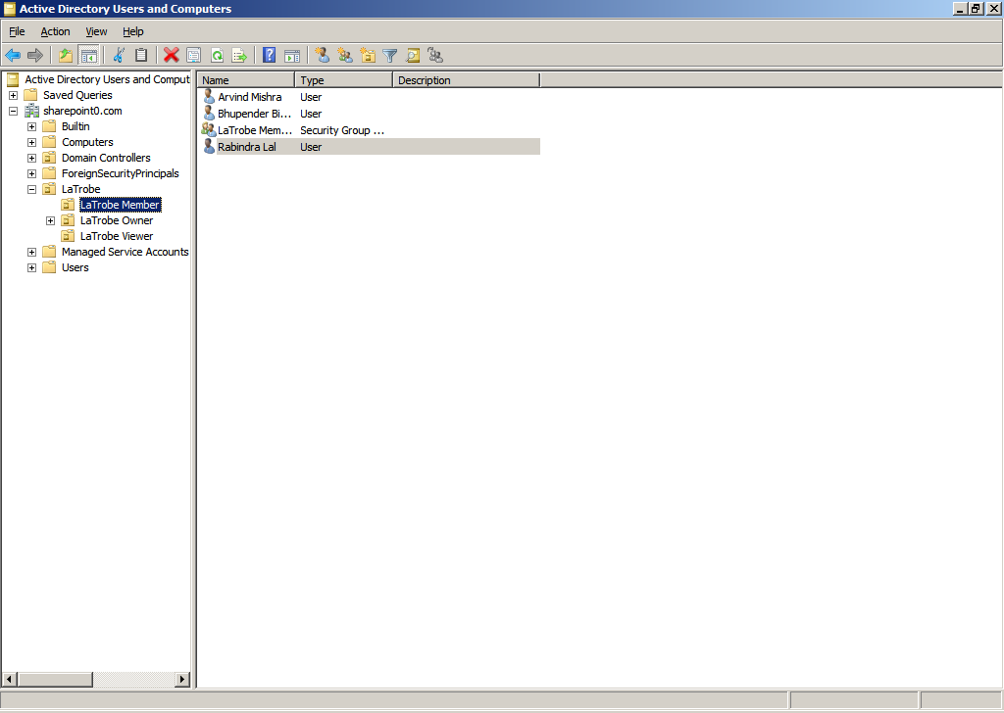

1. **Right click** on the **user** created in **Step 54**. Click **Properties**

**NOTE**: For example, **Anu Sahni** is the user in our case

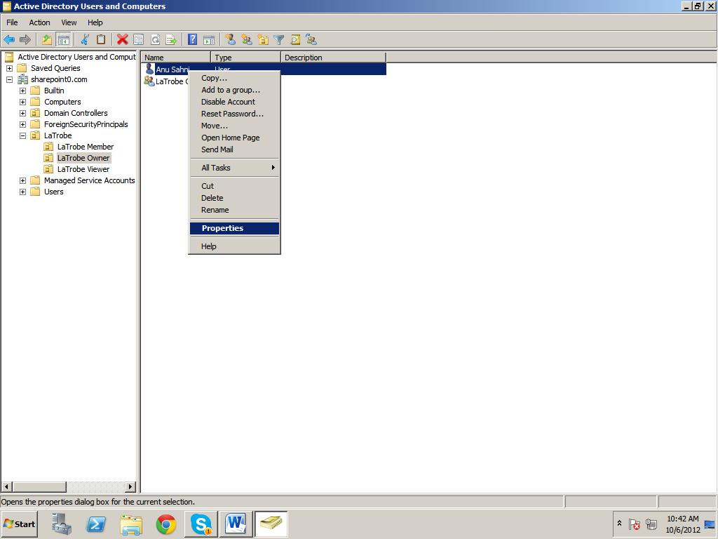

1. Enter the **Email** address of the user. Click **Member Of**

**NOTE**: For example, the **email** in our case is [**anu@softedge-systems.com**](mailto:anu@softedge-systems.com)

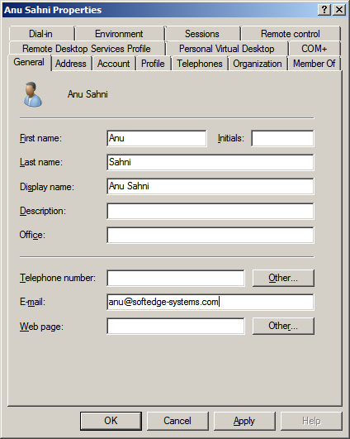

1. Click **Add**

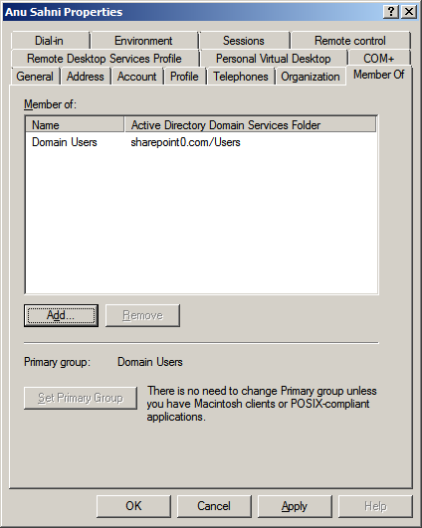

1. Click **Advanced**



1. Click **Find Now**



1. Select **LaTrobe Owner** and click **OK**

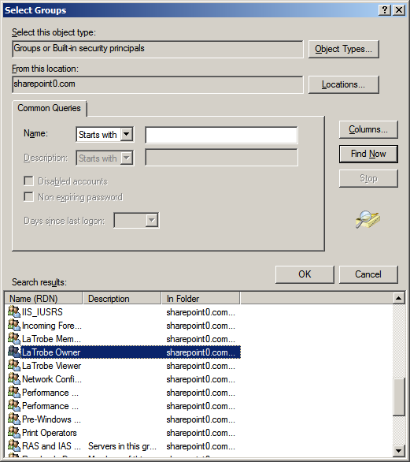

1. Click **OK**

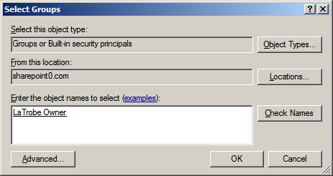

1. Click **Apply**

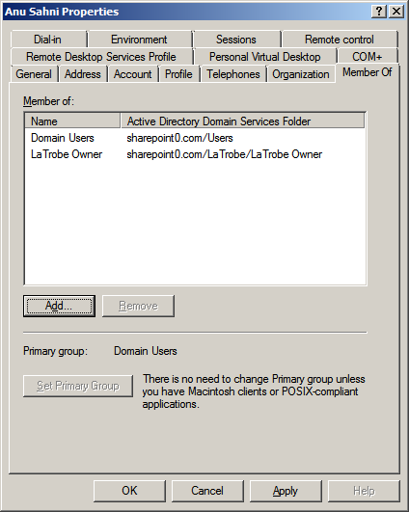

1. Click **OK**

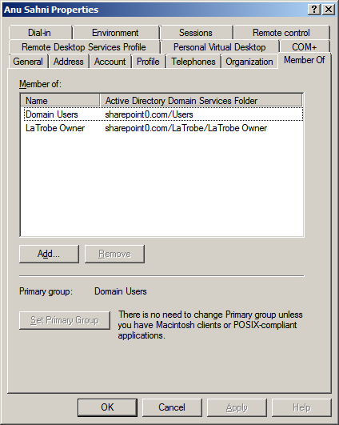

1. **Repeat** **Steps 67 to 80** to **add** **additional** **users** in the group **LaTrobe Owner**

**NOTE**: For example, we have added the users **Vinci Parashar** and **Rajesh Kumar** in the group **LaTrobe Owner**

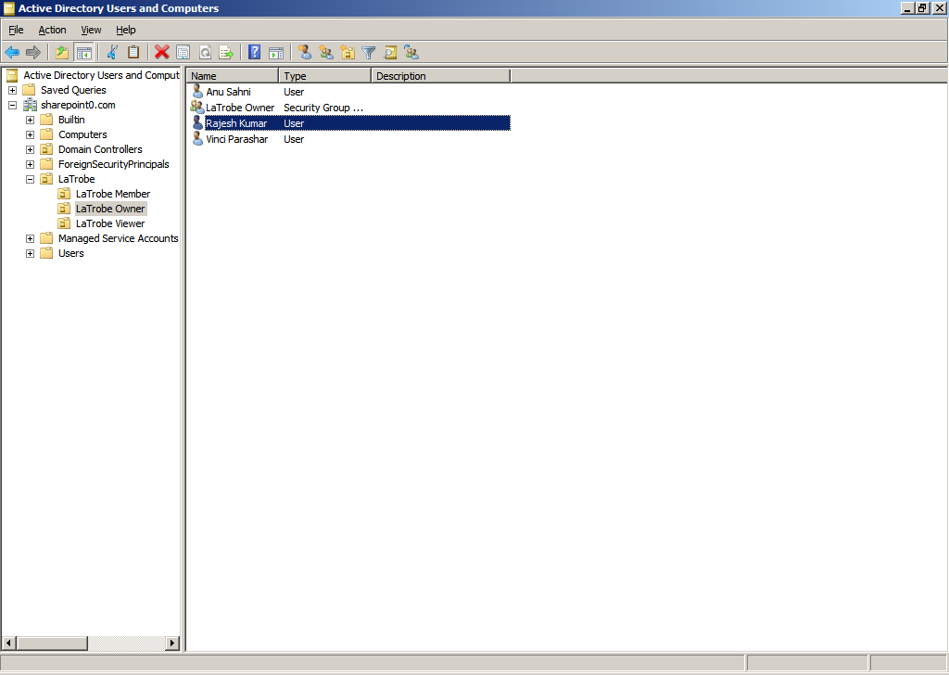

# 6. Creating System Users

1. **Right click** on **Users**. Click **New** 🡪 **User**

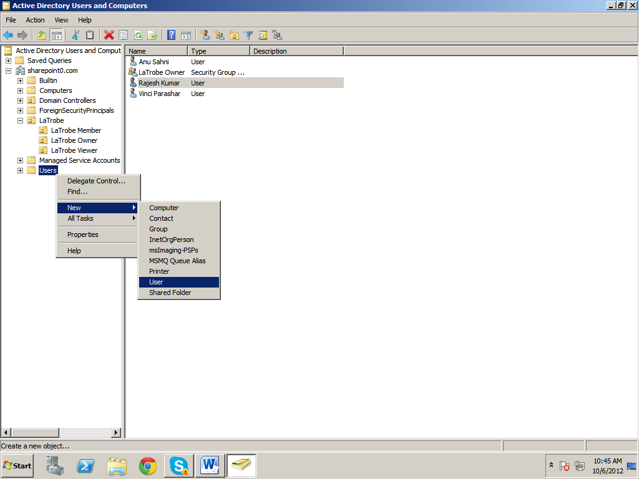

1. **Enter** the **details**, that is, **First name, Initials, Last name** and **User logon name**

**NOTE**: For example, **First name** is **SP**, **Last name** is **Admin** and **User logon name** is **spadmin** in our case

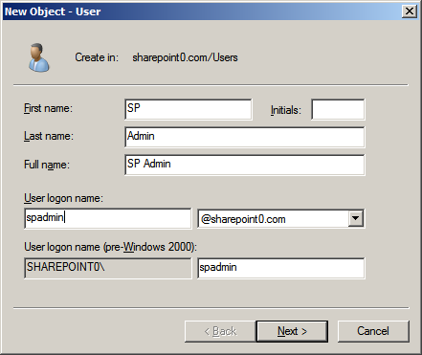

1. Enter **Password** and **Confirm Password**. **Disable** the checkbox **User must change password at next logon**. **Enable** the following checkboxes
2. **User cannot change password**
3. **Password never expires**

**NOTE**: Make sure the checkbox **Account is disabled** has been **unchecked**

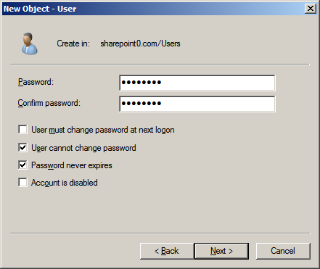

1. Click **Finish**

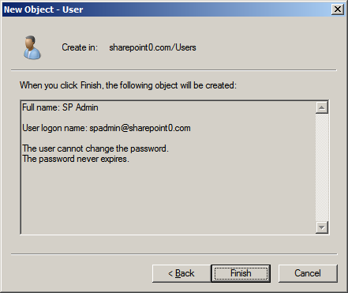

1. Click **Users**

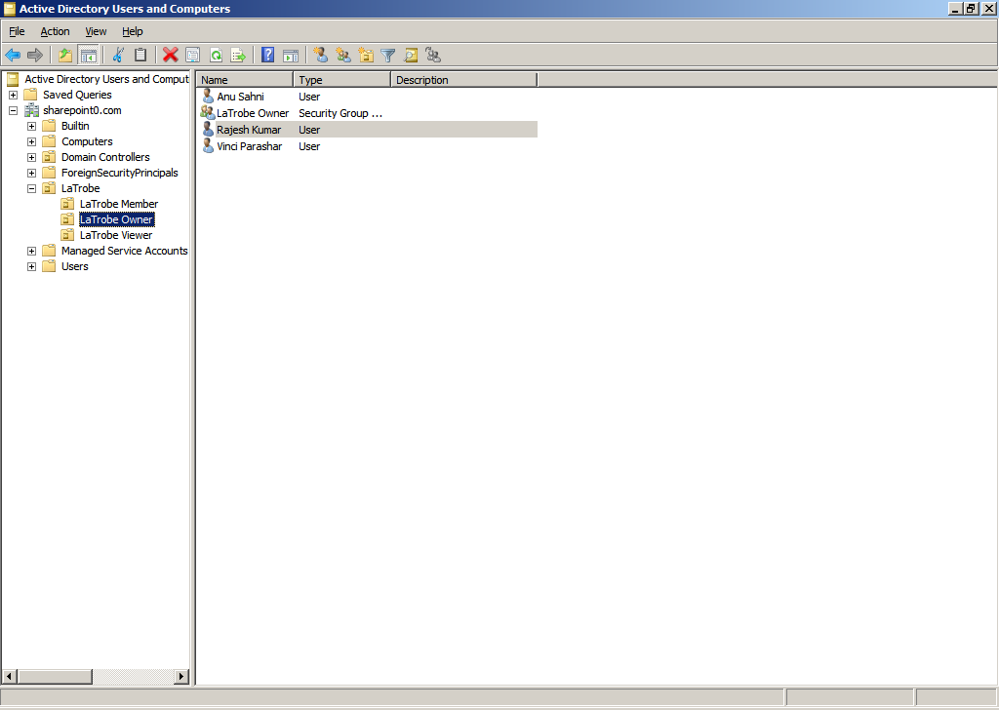

1. The user **SP Admin** has been **added**

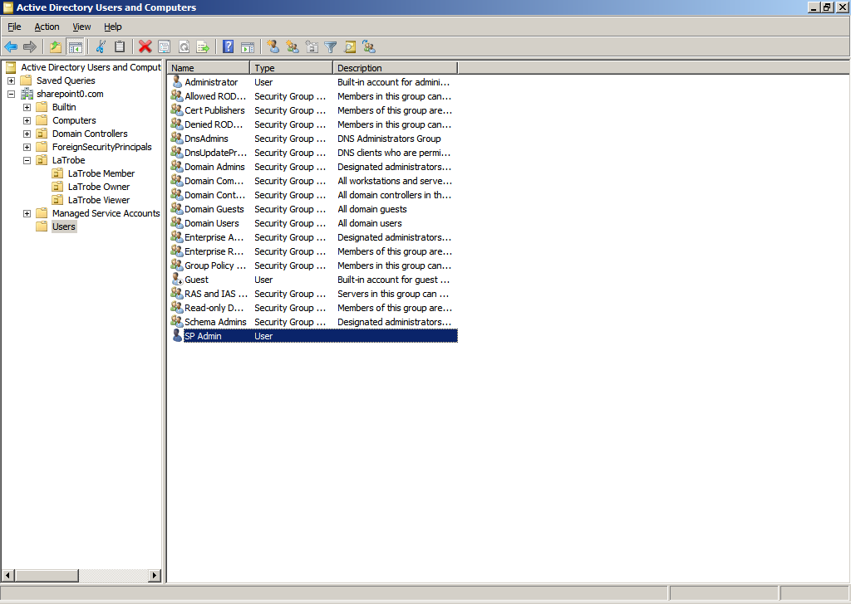

1. **Repeat Steps 61 to 64** to **add** the following **users**

|  |  |  |  |
| --- | --- | --- | --- |
| First Name | Last Name | user login name | Password |
| SP | Admin | spadmin | soft@123 |
| SP | Farm | spfarm | soft@123 |
| SP | Services | spservices | soft@123 |
| SQL | Srvc | sqlsrvc | soft@123 |
| SQL | Admin | sqladmin | soft@123 |

1. All the **users** have been **added** successfully

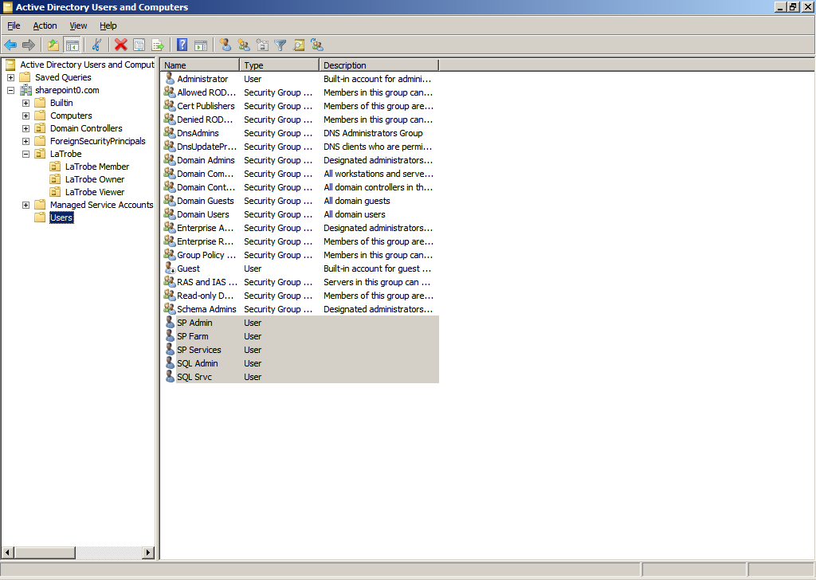

1. **Right click** on the user **SP Farm**. Click **Properties**

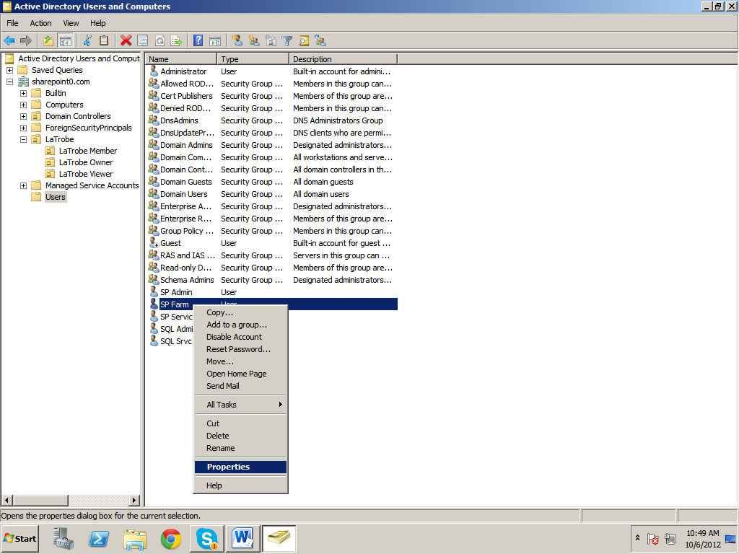

1. Click **Member Of**

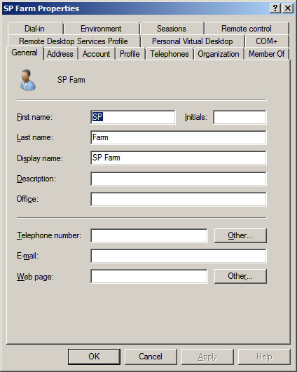

1. Click **Add**

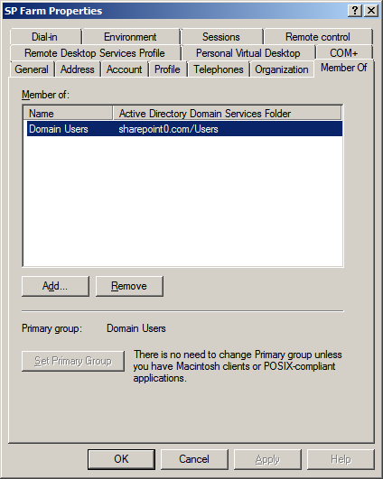

1. Click **Advanced**

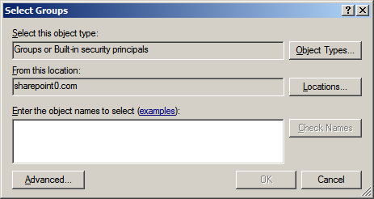

1. Click **Find Now**



1. Select **Replicator** and click **OK**

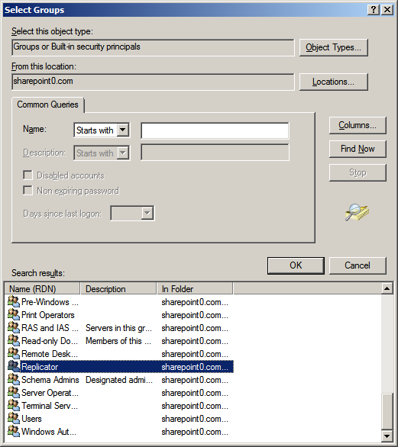

1. Click **OK**

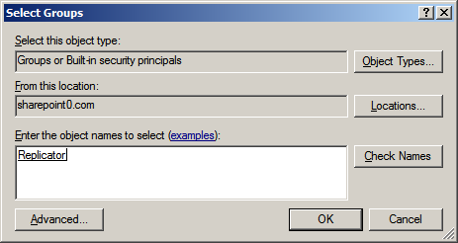

1. Click **Apply**

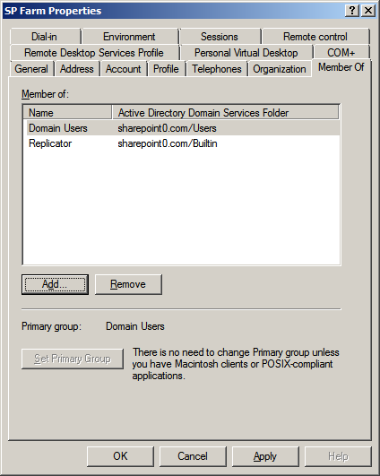

1. Click **OK**

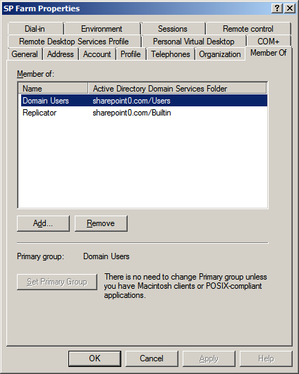

***Once the document has been followed, the following has been completed:***

1. AD has been created
2. Organizational groups have been created
3. Users have been added to the groups
4. System users have been added